#### HANDS Dissemination

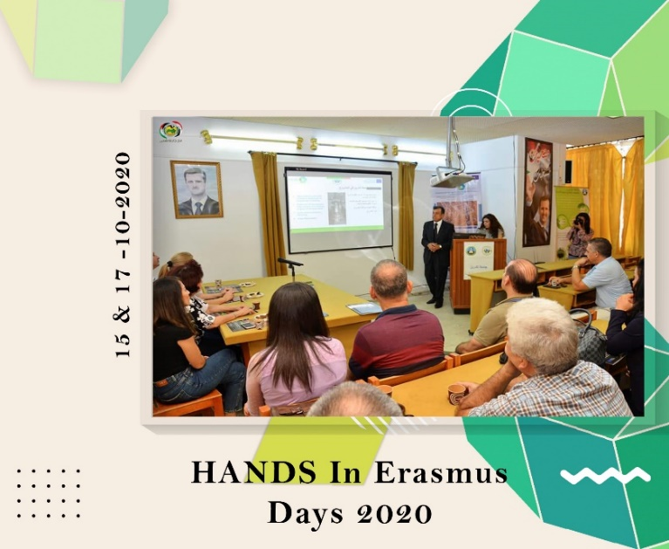**HANDS Dissemination at Erasmus+ Online Days**

**WP 8: DISSEMINATION & EXPLOITATION**

**Date:** Saturday, 17/10/2020  
**Organizer:** The University of Jordan / Al-Zaytoonah University of Jordan  
**Location:** Online via Zoom

The HANDS project participated in Erasmus Days events with presentations and discussions highlighting project goals, impact, and collaborations around traditional crafts in Jordan and Syria. The event included presentations showcasing HANDS courses implemented in Syrian universities, specific crafts, and applications in architecture and interior design. Craftsmen's role in the project and e-marketing strategies were discussed, in addition to discussions on architecture, crafts, and e-marketing with university representatives.